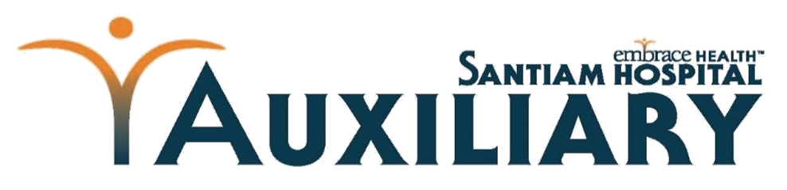

Auxiliary Scholarship Program

2021
-
2022
Scholarship Application

1401
North Tenth Avenue
Stayton, Oregon 973
8
3

Applicant’s name __________________________________________________________________________________
Mailing address (if different) _________________________________________________________________________
Email address ___________________________________ Phone (home) _________________ Cell_________________
Current school ___________________________________ Address of current school ___________________________
College Applying or Accepted _____________________________ Program of Study_____________________________
Are you a Santiam Hospital Youth Volunteer? Y N Are you a Santiam Hospital Employee? Y N
Explain your career goals, field of study, and reasons for choosing this field:

Please submit the following, in order.
- Completed application.
- A current picture (4x6) attached to the application, for our display at events.
- Current official or unofficial transcripts.
- Resume which includes a list of activities list (sports, volunteer service, work, awards

Initials indicating the application instruction sheet has been read and understood ________

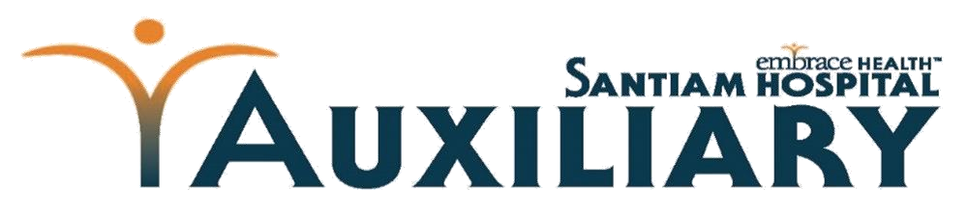

Auxiliary Scholarship Program
2021 Information Sheet

1401
North Tenth Avenue
Stayton, Oregon
973
8
3

Throughout the year our Auxiliary members participate in several fundraising activities to raise money for our scholarship program and hospital support. Our members operate the hospital gift shop, sell poinsettias, tulips, and host a fall fashion show and a breakfast. Unfortunately, last year, due to social distancing requirements we were unable to have fundraising activities.
In 2020 we were able to give over twelve thousand dollars to local students and have budgeted ten thousand for this year.
To be eligible you must live within our service area. This includes Stayton, Lyons, Mill City, Scio, Jefferson,
Aumsville, Gates, Idanha, Marion, Turner, West Stayton, and Sublimity. Please note that Silverton, Salem, Lebanon, and Albany are excluded because these hospitals have their own scholarship programs for their service areas. If you believe you live in our service area but your town is not listed please feel free to contact us. You do not have to be a Santiam Hospital Junior volunteer to qualify.
You must be pursuing a career in a healthcare industry (MD/DO, pre-med, nursing (all inclusive), radiology, Speech, Occupational and Physical Therapy, EMT, pharmacy). If your field of study is not listed, please contact us for clarification prior to applying. Dental, veterinarian, administration, and nutritional fields of study are excluded.
We will begin accepting applications by email on Jan. 31, 2021. Email address is Scholarship@santiamhosptial.org. Application packets must be complete and received no later than five o’clock on the first Friday in April (April 2, 2021). It must arrive before the deadline to qualify.
You must be willing to attend an interview, via Zoom. The tentative date for interviews is the third week in April, (April 12-16, 2021). Interviews last approximately fifteen minutes. One of the Auxiliary members will call you with an appoint date and time if you are eligible for an interview. You will be sent an email with the Zoom address prior to the meeting date and time.
We will make every attempt to notify each applicant with results within two weeks of the interview. If selected and in high school, we will send your school notification of your award and a certificate for presentation at your awards ceremony.
To receive awards, you must be accepted by an accredited school, college, or hospital program studying in a qualified field. It will be your responsibility to send us, via email (Scholarship@santiamhosptial.org) the name of your school, financial aid office address, and your student ID by July 15, 2021. Checks will be mailed directly to the school by August 15, 2021.
Successful applicants are only eligible for one scholarship.
For more information, please contact Genny Baldwin at Scholarship@santiamhosptial.org

